LEE CARTER MODEL FOR FITTING MORTALITY OF INDIAN POPULATION BASED ON LIFE TABLE DATA

SUBMITTED BY:
Rajdeep Saha

CIN No.: 17-300-4-07-0404
Registration no.: A01-1112-0726-17

3rd YEAR

B.Sc. Statistics Honours

Department Of Science

SUPERVISED BY: Prof. Madhura Dasgupta

ST. XAVIER’S COLLEGE (AUTONOMOUS), KOLKATA

STUDENT’S DECLARATION

I,Rajdeep Saha, hereby declare that, the project work entitled “Lee Carter Model For Fitting Mortality of Indian Population Based on Life Table Data” submitted to St. Xavier’s College (Autonomous), Kolkata,is a record of an original work done by me under the guidance of Prof. Madhura Dasgupta and this project work is submitted in the partial fulfillment of the requirements for the award of the degree of Bachelor of Science (Honours).
I affirm that I have identified all my sources and that no part of my dissertation paper uses unacknowledged materials.

Signature: 
Name: Rajdeep Saha

Address: Anandamath, South Mathpara Place: Ichapur

Dated: 30th April, 2020

ACKNOWLEDGEMENT

I take this opportunity to express my sincere gratitude and deep regards to my project guide Prof. Madhura Dasgupta for her exemplary guidance, monitoring and constant encouragement throughout the course of this project. Her blessings, help, time to time guidance will carry me a long way in the journey of life which I am about to embark.
I would also like to thank Fr. Principal Dr. Dominic Savio S.J. and the college authorities for giving me the chance to do the project and for providing the environment and necessary facilities required for the completion of my project. I would also like to thank my College Library for having provided various reference books related to my project.
I would like to thank my department professors for teaching all the necessary topics with immense care which was needed to make the project fruitful.
Finally, I would like to extend my gratitude and thanks to my parents. Without their constant support and encouragement, it would not have been possible for me to proceed with my effort.

CONTENTS

Topic Name | Page No.
1.Introduction | 5
2. Data Description | 6
3. Graphical Representation of Mortality over the Years | 8
4 .Lee Carter Model and Parameter Estimation | 11
5. An alternative approach of estimating the parameters of the  Lee Carter model | 14
6. Fitting of Lee Carter Model to Indian Mortality data | 17
7. Application of Lee-Carter Model | 26
8.Conclusion | 27
9.References | 30

- Introduction:

What is mortality?
Mortality is defined as the branch of demographical analysis which studies the rates and causes of deaths of a population as a whole. It acts as an indicator as a general welfare of a country’s population.

Why fitting of mortality rates is important?
The importance of mortality rates can be looked from the point of view of death in an individual’s life as well as their potential to bring improvement in the health status of a whole community.
Large changes in the mortality rates in a relatively shorter period of time may come up with a challenge to the researchers of demographic and actuarial science. For example, in India death rates has reduced to a large extent in the last few decades due to socio economic development.

Mortality modeling and forecasting have been one of the most important field of interest for the researchers of actuarial science and demography. During last century, many countries have experienced a considerable reduction in mortality rates due to socio economic development.

This decline brings a very serious financial exposure for insurance providers which arises the need to develop methods for fitting and forecasting mortality rates.
Lee Carter (1992) established the first mortality model with stochastic forecast. Because of the simplicity of parameter estimation the model became popular. The model has been used by several countries the modeling and forecasting mortality rates.

- Data Description:

A life table presents a comprehensive picture of a population that gets depleted systematically through deaths at each age (or in a certain age interval) and thus portrays process of life itself. As used currently it is a statistical history of a hypothetical cohort of persons born at an instant of time followed through till the last person dies.
Our study is based on the data obtained from abridged life table on Indian population for 5 year basis from 1971 to 2010.These life tables are taken from www.lifetable.de .In these life
tables, life table functions are computed for broader age groups. In the actual data, life table for age interval 0,1-4,5-9,……,70+ are available. This type of life table is called Greville’s Life Table.

In these types of life tables, the usual life table functions are computed for the age interval of length ‘l’
- In each of the SRS based abridged life tables we have 4 columns; lx`, nqx`, nLx`,e0x`

- lx` :total no. of persons expected to attain exact age ‘x`’.

- ndx`: no. of persons dying in the age interval (x`,x`+n) after attaining exact age ‘x`’.

- nqx`: probability that a person will die in the age interval(x`,x`+n) after attaining exact age ‘x`’.
- nLx`: total no. of years lived by the cohort in an aggregate in the age interval(x`,x`+n).

- From these life table we have obtained ndx` by using

ndx`= nqx`*lx` (2.1)

We also derived the 5 year wise Age Group Specific Central Death Rates (mx,t) as,

mx,t= ndx / nLx (2.2)

mx,t is also known as Central Rate of Mortality or Central Mortality Rate for time period ‘t’

,where,

‘x’ denotes the age group under consideration (here in our data 0,1-4,5-9, ,65-

69,70+ )

‘t’ denotes the period(5 year interval)of life table under consideration(here in our data,(t=1971-75,1976-80, ,2006-10)

Data on 5 year wise age group specific central death rates for Indian Male and Female populations are reported in Table 1 and Table 2

Graphical Representation of Mortality over the Years:

Table1:5 year wise age group specific central death rates for Indian Male population during 1971-75 to 2006-2010

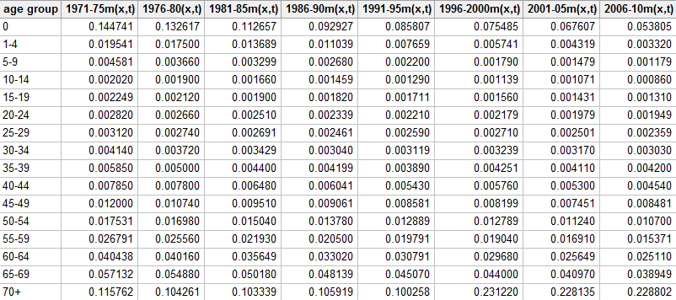

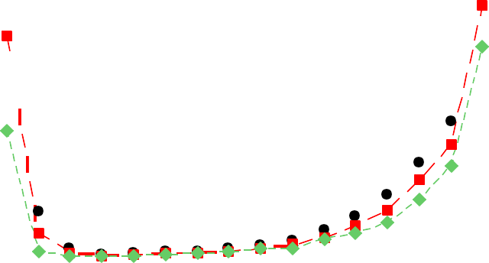Figure 1:Pattern of age group specific central death rates for Indian Male Population

Pattern of age group specific central death rates for Indian Male Population
0.16

0.14

0.12

0.10

0.08

0.06

0.04

0.02

0.00

age group
Variable
1971-75m(x,t)
1986-90m(x,t)
2006-10m(x,t)
age specific central death rate

To illustrate the improvement in Indian male mortality we have plotted age group specific central death rates for Indian male.
Overall there has been a decline in mortality rates of Indian male during 1971-2010.We observed higher level of decline in mortality rates during 2006-2010 compared to 1971-75.

Table2:5 year wise age group specific central death rates for Indian Female population during 1971-75 to 2006-2010

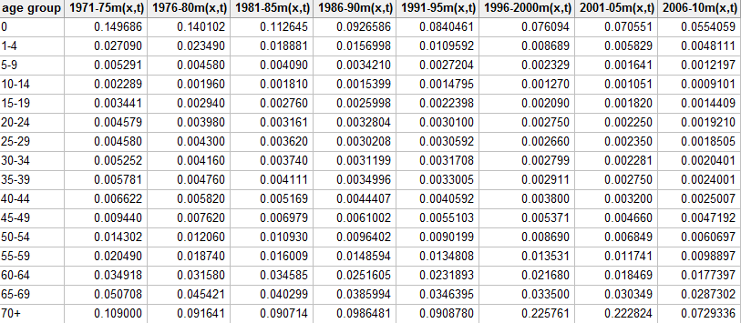

Figure 2:Pattern of age group specific central death rates for Indian Female Population

Pattern of age group specific central death rates for Indian Female Population
0.16

0.14

0.12

0.10

0.08

0.06

0.04

0.02

0.00

age group
Variable
1971-75m(x,t)
1986-90m(x,t)
2006-10m(x,t)
age specific cental death rate

To illustrate the improvement in Indian female mortality we have plotted age group specific central death rates for Indian female.
Overall there has been a decline in mortality rates for Indian female during 1971-2010.We observed higher level of decline in mortality rates during 2006-2010 compared to 1971-75.

4 .Lee Carter Model and Parameter Estimation:

Model:

Lee and Carter first established stochastic mortality model for modeling human

mortality. The model is given by,

………(4.1)
ln(m_{x,t})=a_{x}+b_{x}k_{t}+e_{x,t}

where,

x: age group under consideration(here in our data, x=0,1-4,5-9,……,65-69,70+)

t: period of life table under consideration(here in our data, t=1971-75,1976-80,……,2006-2010) mx,t: central rate of mortality for age group x at time ‘t’
ax: coefficient that describes average age specific pattern of mortality kt: denotes the time trend for the general mortality

bx: coefficient which measures sensitivity of ln(mx,t) at age group x as the kt varies ex,t: error associated with age group x and time’t’

Assumption:

The assumptions that Lee Carter made for estimating the parameters of the proposed model

are,

∑_{x} b_{x}=1 (ii)∑_{t} k_{t}=0

  - Estimation of the parameters:

Lee-Carter suggested to apply singular value decomposition method to estimate the parameters of the model.
We have,

ln(m_{x,t})=a_{x}+b_{x}k_{t}

for each age group, we have values for 8 time intervals. So,summing over time, we get,

∑_{t} ln(m_{x,t})= ∑_{t} (a_{x}+b_{x}k_{t}) Or, ∑_{t} ln(m_{x,t})= ∑_{t} a_{x}+ ∑_{t} b_{x}k_{t} Or, ∑_{t} ln(m_{x,t})= ∑_{t} a_{x}+ b_{x}∑_{t}k_{t} Or, ∑_{t} ln(m_{x,t})= ∑_{t} a_{x} [∑_{t} k_{t}=0]
a_{x}̂= ^{𝟏}∑_{t} ln(m_{x,t})
𝟖

we have obtained estimated ax̂ for respective age group as,

Age group | ax̂(males) | ax̂(females)
0 | -2.39605 | -2.37795
1-4 | -4.74534 | -4.40307
5-9 | -6.04199 | -5.86195
10-14 | -6.59121 | -6.51878
15-19 | -6.35618 | -6.05873
20-24 | -6.06937 | -5.80534
25-29 | -5.93779 | -5.79045
30-34 | -5.70104 | -5.75002
35-39 | -5.41442 | -5.64141
40-44 | -5.10707 | -5.45763
45-49 | -4.69339 | -5.09459
50-54 | -4.29218 | -4.67066
55-59 | -3.89156 | -4.23485
60-64 | -3.43914 | -3.68448

For obtaining estimated parameters bx̂ and kt̂ , we can use Singular Value decomposition Method on matrix S, where S is given by,

sxt= ln(mx,t)- ax̂ (4.2)

Note that, S is a 16*8 matrix whose elements are obtained from equation (4.2)

On doing Singular Value Decomposition on S,we have got the following form S=U∑V^{T}

Where ∑ is the diagonal matrix, diagonal elements being the Eigen Values of the matrix SS^{T.} U and V are the corresponding Left and Right Singular vectors of S.
Lee Carter suggested that the approximation to the 1st term of the singular value decomposition of S would give the estimated value bx̂ and kt̂
In other words according to Lee Carter, the 1st column of left singular matrix ie U would give the estimated value bx̂ and the 1st column of right singular matrix ie V would give the estimated value kt̂
The Lee Carter Model is so popular due to its simplicity for the parameter estimation by the Singular Value Decomposition method.

An Alternative Approach of estimating the Parameters of the Lee Carter Model:

As an alternative way of SVD method, Lee Carter suggested a slightly approximated method to estimate the parameters of the model.

We can see that this model can’t be fitted by ordinary regression method, because there are no given regressors. Thus in order to obtain a least square solution of equation (3),we apply a close approximation assuming the error terms are homoscedastic.
We have,

∑_{x} ln(m_{x,t})=∑_{x} (a_{x}+b_{x}k_{t}) Or, ∑_{x} ln(m_{x,t})=∑_{x}a_{x} + ∑_{x} b_{x}k_{t} Or, ∑_{x} {ln(m_{x,t})-a_{x} }= k_{t}∑_{x} b_{x}

…………(as, ∑_{x} b_{x} =1)
k_{t}̂=∑_{x}{ln(m_{x,t})-a_{x}̂ }

Time Interval | kt̂(Males) | kt̂(Females)
1971-75 | 4.70424 | 6.76470
1976-80 | 3.36151 | 4.48144
1981-85 | 1.52039 | 2.63195
1986-90 | 0.03838 | 0.60218
1991-95 | -1.29917 | -1.01617
1996-2000 | -1.23955 | -1.52106
2001-05 | -2.86194 | -4.22619
2006-10 | -4.22387 | -7.71685

We also see that the estimated values kt̂ for both males and females add up to 0,which meets one of the assumptions suggested by Lee-Carter.
An estimate of bx, suggested by Lee Carter ,is obtained by regressing ∑t (ln(mx,t)-ax ) on kt, which can be obtained by minimizing the sum of squares of errors

i.e. , we have to minimize,

E= ∑ e ² = ∑

{ln(m )-a -b

k }²

t x,t t
x,t
x x t

Differentiating both sides wrt bx and equating with 0 we get,
𝑑𝐸 = 0
𝑑bx

Or, ∑_{t} k_{t}{ln(m_{x,t})-a_{x}-b_{x}k_{t}} = 0 Or, ∑_{t} k_{t}{ln(m_{x,t})-a_{x}} = b_{x}∑_{t} k_{t}²
b_{x}̂=∑_{t} k_{t}(ln(m_{x,t})-a_{x} )/ ∑_{t} k_{t} ²

Age group | bx̂ (males) | bx̂(females)
0 | 0.110042 | 0.072326
1-4 | 0.209365 | 0.133606
5-9 | 0.150912 | 0.107926
10-14 | 0.095375 | 0.066248
15-19 | 0.060361 | 0.059455
20-24 | 0.043519 | 0.059153
25-29 | 0.023988 | 0.064323
30-34 | 0.032260 | 0.065239
35-39 | 0.037757 | 0.061511
40-44 | 0.061172 | 0.067962
45-49 | 0.046168 | 0.050168
50-54 | 0.060590 | 0.060058
55-59 | 0.061660 | 0.050608
60-64 | 0.058932 | 0.054490
65-69 | 0.044041 | 0.040995
70+ | -0.092584 | -0.014067

We also see that the estimated values of bx for both the males and the females add up to very close to 1,which meets one of the assumptions suggested by Lee-Carter.

Fitting of Lee Carter Model to Indian Mortality Data:
Here, we represent the results of estimation of parameters in Lee Carter model for the population of India based on SRS based mortality tables available from 1971-75 to 2006-2010.
The quantity kt being time independent, is same for all age group in a certain age interval and for each ‘x’(age interval),we take the corresponding estimates of ax & bx to get ln(mx,t).After obtaining the estimated value of ln(mx,t),we can easily obtain the expected value of Age Group Specific Central Death Rate.
In the following tables we have shown the observed value and the expected value of Age Group Specific Central Death Rate for males and females respectively for some selected time intervals and plotted the graphs of observed rates and fitted rates.

Age Group | Obsd. Male (1971-75) | Fitted Male (1971-75)
0 | 0.144741 | 0.152837
1-4 | 0.019541 | 0.023273
5-9 | 0.004581 | 0.004834
10-14 | 0.002020 | 0.002149
15-19 | 0.002249 | 0.002306
20-24 | 0.002820 | 0.002838
25-29 | 0.003120 | 0.002953
30-34 | 0.004140 | 0.003890
35-39 | 0.005850 | 0.005317
40-44 | 0.007850 | 0.008072
45-49 | 0.012000 | 0.011376
50-54 | 0.017531 | 0.018185
55-59 | 0.026791 | 0.027283
60-64 | 0.040438 | 0.042345
65-69 | 0.057132 | 0.057867
70+ | 0.115762 | 0.115477

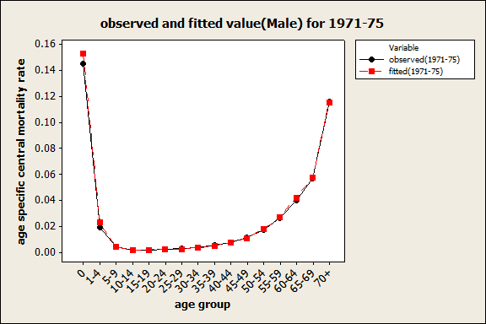

Age Group | Obsd. Male (1981-85) | Fitted Male (1981-85)
0 | 0.112657 | 0.107664
1-4 | 0.013689 | 0.011950
5-9 | 0.003299 | 0.002990
10-14 | 0.001660 | 0.001587
15-19 | 0.001900 | 0.001903
20-24 | 0.002510 | 0.002471
25-29 | 0.002691 | 0.002736
30-34 | 0.003429 | 0.003511
35-39 | 0.004400 | 0.004715
40-44 | 0.006480 | 0.006644
45-49 | 0.009510 | 0.009821
50-54 | 0.015040 | 0.014995
55-59 | 0.021930 | 0.022420
60-64 | 0.035649 | 0.035101
65-69 | 0.050180 | 0.050296
70+ | 0.103339 | 0.122838

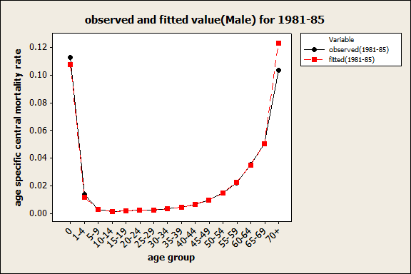

Age Group | Obsd. Male (1991-95) | Fitted Male (1991-95)
0 | 0.085807 | 0.078945
1-4 | 0.007659 | 0.006622
5-9 | 0.002200 | 0.001954
10-14 | 0.001290 | 0.001212
15-19 | 0.001711 | 0.001605
20-24 | 0.002210 | 0.002186
25-29 | 0.002590 | 0.002557
30-34 | 0.003119 | 0.003205
35-39 | 0.003890 | 0.004239
40-44 | 0.005430 | 0.005591
45-49 | 0.008581 | 0.008623
50-54 | 0.012889 | 0.012640
55-59 | 0.019791 | 0.018842
60-64 | 0.030791 | 0.029727
65-69 | 0.045070 | 0.044423
70+ | 0.100258 | 0.109479

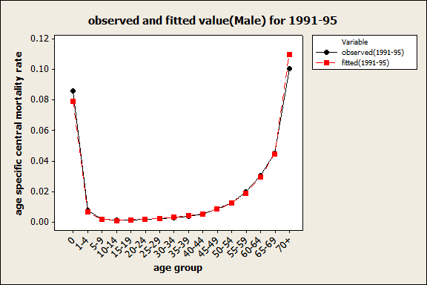

Age Group | Obsd. Male (2006-10) | Fitted Male (2006-10)
0 | 0.053805 | 0.057220
1-4 | 0.003320 | 0.003590
5-9 | 0.001180 | 0.001257
10-14 | 0.000860 | 0.000917
15-19 | 0.001310 | 0.001345
20-24 | 0.001949 | 0.001924
25-29 | 0.002359 | 0.002384
30-34 | 0.003030 | 0.002917
35-39 | 0.004200 | 0.003796
40-44 | 0.004540 | 0.004675
45-49 | 0.008481 | 0.007533
50-54 | 0.010700 | 0.010587
55-59 | 0.015371 | 0.015733
60-64 | 0.025110 | 0.025021
65-69 | 0.038949 | 0.039054
70+ | 0.088802 | 0.119075

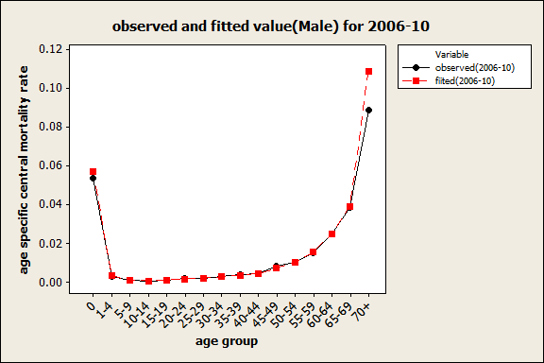

Age Group | Obsd. Female (1971-75) | Fitted Female (1971-75)
0 | 0.149686 | 0.151271
1-4 | 0.027090 | 0.030220
5-9 | 0.005291 | 0.005906
10-14 | 0.002289 | 0.002310
15-19 | 0.003441 | 0.003495
20-24 | 0.004579 | 0.004493
25-29 | 0.004580 | 0.004723
30-34 | 0.005252 | 0.004948
35-39 | 0.005781 | 0.005379
40-44 | 0.006622 | 0.006752
45-49 | 0.009440 | 0.008607
50-54 | 0.014302 | 0.014061
55-59 | 0.020490 | 0.020394
60-64 | 0.034918 | 0.036303
65-69 | 0.050708 | 0.049017
70+ | 0.109000 | 0.104221

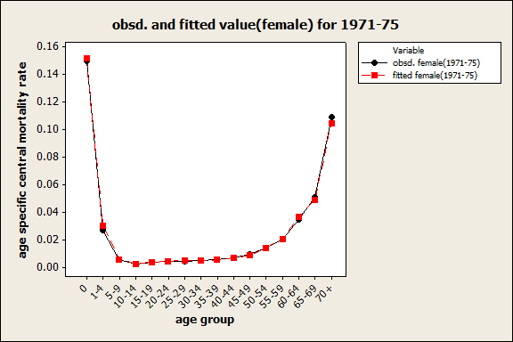

Age Group | Obsd. Female (1981-85) | Fitted Female (1981-85)
0 | 0.112645 | 0.112187
1-4 | 0.018881 | 0.017398
5-9 | 0.004090 | 0.003781
10-14 | 0.001810 | 0.001757
15-19 | 0.002760 | 0.002733
20-24 | 0.003161 | 0.003519
25-29 | 0.003620 | 0.003620
30-34 | 0.003740 | 0.003779
35-39 | 0.004111 | 0.004171
40-44 | 0.005169 | 0.005099
45-49 | 0.006979 | 0.006995
50-54 | 0.010930 | 0.010970
55-59 | 0.016009 | 0.016545
60-64 | 0.034585 | 0.028983
65-69 | 0.040299 | 0.041378
70+ | 0.090714 | 0.110460

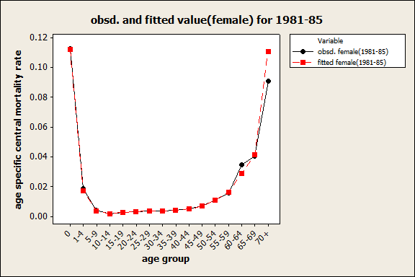

Age Group | Obsd. Female (1991-95) | Fitted Female (1991-95)
0 | 0.0840461 | 0.086169
1-4 | 0.0109592 | 0.010686
5-9 | 0.0027204 | 0.002550
10-14 | 0.0014795 | 0.001379
15-19 | 0.0022398 | 0.002200
20-24 | 0.0030100 | 0.002836
25-29 | 0.0030592 | 0.002863
30-34 | 0.0031708 | 0.002979
35-39 | 0.0033005 | 0.003333
40-44 | 0.0040592 | 0.003979
45-49 | 0.0055103 | 0.005825
50-54 | 0.0090199 | 0.008812
55-59 | 0.0134808 | 0.013756
60-64 | 0.0231893 | 0.023758
65-69 | 0.0346395 | 0.035630
70+ | 0.0908780 | 0.116277

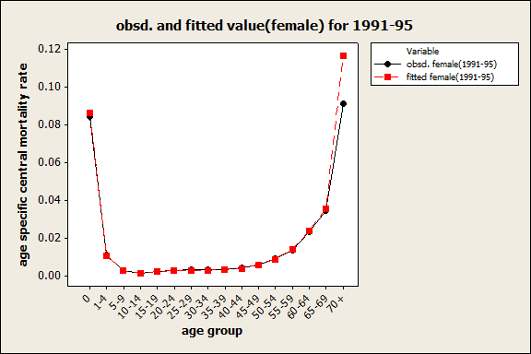

Age Group | Obsd. Female (2006-10) | Fitted Female (2006-10)
0 | 0.055406 | 0.053073
1-4 | 0.004811 | 0.004365
5-9 | 0.001220 | 0.001237
10-14 | 0.000910 | 0.000885
15-19 | 0.001441 | 0.001477
20-24 | 0.001921 | 0.001908
25-29 | 0.001851 | 0.001861
30-34 | 0.002040 | 0.001924
35-39 | 0.002400 | 0.002207
40-44 | 0.002501 | 0.002524
45-49 | 0.004719 | 0.004162
50-54 | 0.006067 | 0.005892
55-59 | 0.009890 | 0.009800
60-64 | 0.017740 | 0.016491
65-69 | 0.028730 | 0.027072
70+ | 0.072934 | 0.117770

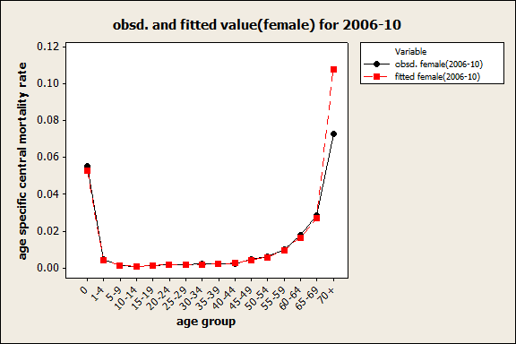

The obtained results from the table and the graphs above indicate that the fitted mortality rates for males obtained by fitting the Lee Carter model are generally very close to the observed (actual) mortality rates which show that the fit is very good.

Application of Lee Carter Model:

Forecasting is the main aim behind the stochastic modeling of Lee Carter model. One of the notable significance of this model is, once it is fitted (ie, once the values of ax , bx & kt are found),only the mortality index (kt ) over time needs to be obtained for future time intervals.
Lee-Carter applied Auto Regressive Integrated Moving Average (ARIMA) process and proposed its order (0,1,0) (ie, random walk with drift) for modeling mortality index kt .
After obtaining kt for the required time interval, we can obtain the logarithm value of age specific central death rate for each of the age group and after that we will take exponential of those values to obtain the required value of age specific central death rate.

Application in Health Sector:

The forecasted central mortality rates is used to present a clear picture of gender wise age specific mortality prevailing in the country which can be used to form plans to reduce the mortality if it is high specially in case of Infant Mortality Rates.

Actuarial Application:

Forecasted values of Age Specific Central Death Rates in terms of number of deaths per 1,00,000 people are used in the evaluation of actuarial quantities.
From the forecasted values of the Central Mortality Rates,life expectancies are employed by the insurance companies for determining rates of premium, Net Single Premium(NSP-present value of the future death benefit) for policies of persons at different age groups while government or a private firm may use it for determining rates of retirement benefits for its employees.

Conclusion:

- At first, we have compared the mortality pattern of Indian males and females graphically.

We have selected three time interval for comparison (1971-75,1986-90,2006-10).

To indicate the improvement in Indian Mortality we have plotted age group specific central mortality rate for Indian males and females. Overall, there has been a decline in India during 1971 to 2010 for both males and females, due to socio economic development such as,
  - Control of Epidemics

  - Urbanization of Population

  - Increase in Medical Facilities

  - Spread of Education

  - Late Marriage(can be regarded as a cause of declining female mortality)

- Next, We have modeled the age group specific central mortality rates of Indian male and female population by using the Lee-Carter model based on 5 year based mortality data from 1971-75 to 2006-10.
Lee Carter suggested SVD (Singular Value Decomposition) Method to estimate the model parameters, but instead of applying direct SVD we have used the model assumptions to estimate ax and kt and then applied least square method to estimate bx.
After estimating the parameters, we have used them to obtain fitted value of age group specific mortality rates for some selected time intervals (1971-75, 1981-85,1991-95,2006-10) for both males and females. We have also plotted observed rates and fitted rates for each of the selected intervals in single graphs.
We have seen that the fitted rates are very much close to observed rates and we got the same cue from the graphs also. Thus, we can conclude that Lee Carter Model can be well used for fitting mortality rates of Indian males and females
We have observed the following, -----

- The general pattern of mortality respectively for both males and females show high infant mortality. Prematurity and low birth weight are the reasons behind this. The first 4 weeks of

births have been considered to have a very high risk of infant death and death during this period is called Neonatal Mortality Rate.
- Mortality trend has shown decreasing trend from year to year. (iii)Mortality improvement has been observed specially in case of infants.

As per the Sample Registration System (SRS) reports, which is published by the Registrar General of India, the IMR(Infant Mortality Rates) has reduced from 63.19 (deaths/1,000 live births) in 2001to 45.10 to 2010.
Various Governmental Schemes like----

  - Janani Shishu Suraksha Karyakaram (JSSK)

  - Newborn Care Concerns (NBCC)

  - Integrated Management of Neonatal and Childhood Illness(IMNCI)

  - Infant and Young Child Feeding Practices(IYCFP) etc has played a pivotal role in declining infant mortality.
- Further Area of Analysis: As Forecasting is the main aim behind fitting a model, we can use

the model for obtaining mortality rates for future periods, which can be applied in various fields(e.g. calculating life expectencies)
It can be noted that, out of 3 parameters of this model, only one parameter is time dependent (i.e., kt).So for forecasting purpose, only this parameter needs to be estimated.

References:

(i)

https://www.google.com/url?sa=t&source=web&rct=j&url=https://sljastats.sljol.info/articles/10.

4038/sljastats.v17i1.7845/galley/5936/download/&ved=2ahUKEwjKz8aSu67oAhXF6XMBHbw

eDrkQFjABegQIChAH&usg=AOvVaw3wOY6gj3z2M5a-mXJVWxOd

(ii)

https://www.google.com/url?sa=t&source=web&rct=j&url=https://arxiv.org/pdf/1811.09622&ve

d=2ahUKEwiTycXpua7oAhXOyTgGHZfUC-

MQFjABegQICxAH&usg=AOvVaw2fzxqxAEoGQ8tkHCGe_u_v

https://www.google.com/url?sa=t&source=web&rct=j&url=https://en.m.wikipedia.org/wiki/Lee

%25E2%2580%2593Carter_model&ved=2ahUKEwiE3ezzuq7oAhX-

83MBHV17CrMQFjAOegQIDRAf&usg=AOvVaw2PxlBXVkXktd7IDxX3I4Rk

https://www.google.com/url?sa=t&source=web&rct=j&url=https://www.cass.city.ac.uk/ data/a

ssets/pdf_file/0005/37157/167ARP.pdf&ved=2ahUKEwjhxZrRu67oAhWHSH0KHYbWBDsQF

jACegQIAhAB&usg=AOvVaw2rcWiN4n2kfXG0SHm5a7Vl&cshid=1584893311256

- Technical Demography-R Ramakumar

